Chapter 7, Solution 32.

(a) 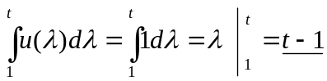
(b) 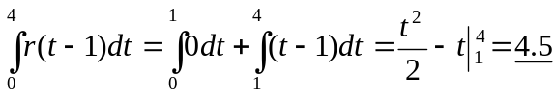
(c ) 